Transort4You

Design Description

Version 2.0

Doc. No.:

Revision History

Date | Version | Description | Author
2010-10-8 | 1.0 | Initial Draft | Toni Pivcevic
2010-10-14 | 1.1 | Added TUA Architecture description | Dino Bartosak
2011-02-26 | 2.0 | New revision of the document | Dajan Zvekic

Table of Contents
1. Introduction 5
1.1 Purpose of this document 5
1.2 Intended Audience 5
1.3 Scope 5
1.4 Definitions and acronyms 5
1.4.1 Definitions 5
1.4.2 Acronyms and abbreviations 5
1.5 Related references 5
2. External interfaces 6
2.1 Transport Unit Application external interfaces 6
2.2 Transport Main Application external interfaces 6
2.3 Transport Web Application external interfaces 6
3. Software architecture 6
3.1 Conceptual design 6
3.2 System specification 7
3.3 Error handling 7
4. Detailed software design 8
4.1 System architecture 8
4.2 Transport model and database design 8
4.3 Transport main application design 10
4.4 Transport unit application 11
4.5 Transport web application 12
5. Approvals 13
6. References 13

Introduction
This document is a written description of a software product. Software designers write design description document in order to give a software development team an overall guidance of the architecture of the software project.

Purpose of this document
This document will identify and describe the overall system design and architecture. Detailed study of this document will provide the reader with a general overview of the system design.

Intended Audience
Intended audience includes:
- Team members for internal usage during development phase of the project
- Team supervisor
- Customer(s)

Scope
The system will be presented to the reader through a component-based description and analysis, since the system itself consists of multiple remotely located components. The system will also be presented through a layered perspective.

Definitions and acronyms

Definitions

Keyword | Definitions
Transport line | One line of transport network.
Route section | Journey on a section of transport line performed by user.
Route | Journey performed by user. Sorted collection of route sections.
Table 1 - Definitions

Acronyms and abbreviations

Acronym or  abbreviation | Definitions
SMS | Short Message Service
Wi-Fi | Wireless Fidelity
Transport4You | Transport For You
TU | Transport Unit
TMA | Transport Main Application
TUA | Transport Unit Application
TWA | Transport Web Application
TM | Transport Model
Table 2 – Acronyms and abbreviations

Related references
- Project specification by SCORE
  - http://score-contest.org/2011/projects/DiNittoRossi.Transport4You.pdf
- Project homepage
  - http://www.fer.hr/rasip/dsd/projects/transport4you1

External interfaces
Transport4U system is consisted from the three separate modules and every module uses external devices for data gathering so the system is very dependent on external interfaces. This section describes separately external interfaces used every module of Transport4U system.

Transport Unit Application external interfaces
Transport unit application (TUA) is system module that is the most dependent on external interfaces. In Table 3 are described all external interfaces used by TUA.

Interface name | Description | Direction
GPRS device | TUA sends data to TMA through GPRS device. | TUA→GPRS device
WIFI device | TUA detects MAC addresses of all users currently in the TU’s WIFI network range. | TUA→WIFI device
Bluetooth device | TUA detects MAC addresses of all users currently in the TU’s Bluetooth network range. | TUA→Bluetooth device
Event Handler | TUA handles events from TU:  - TU arrives at station (i.e. doors open)  - TU leaves station (i.e. doors close) | TU event fire→TUA
GPS device | TUA gets current GPS position from GPS device. | TUA →GPS device
Table 3 – TUA external interfaces

Transport Main Application external interfaces
Transport main application (TMA) is dependent on SMS gateway device, this interface is described in Table 4.

Interface name | Description | Direction
SMS gateway | TMA has to send SMS message notifications to users. | TMA → SMS gateway
Table 4 – TMA external interfaces

Transport Web Application external interfaces
Transport web application (TWA) is dependent on credit-card payment service, this interface is described in Table 5.

Interface name | Description | Direction
Credit-card payment service | TMA has to provide payment by credit-card. | TMA → credit card service
Table 5 – TWA external interfaces
* Direction indicates which component is hidden behind an interface.

Software architecture

Conceptual design
The system is designed in a way that all components are decoupled and the implementations of the components are hidden behind interfaces. This provides us with the possibility for development of new, improved, components without the need to change any existing part of the system. The Transport4U model is a separate part of the system and can be easily reused for similar projects or for the extension of existing components. The system is composed from four main components: Transport model, Transport main application, Transport unit application, and Transport web application. The Component diagram is shown in Figure 1.
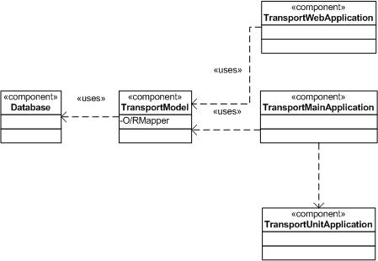
Figure 1 – Transport4U component diagram

There is only one instance of the TMA running on a mainframe server. There is also only one instance of the TWA (for ease of deployment, it can be running on the same mainframes server). There are multiple instances of the TUA and each instance is running on a client machine inside a public transportation unit (e.g. in busses or trams). Interactions and communication protocols between these components are described in latter sections.

System specification
Transport4U system is made of several different components as it is shown in Figure 1. Also, varieties of technologies are used for implementation of these components. Implementation technologies and intended audience are described in Table 6.

Component name | Implementation technologies | Intended audience
TMA | Java, ant | Server side for TUA and TWA
TUA | Java, ant | Transport unit drivers and passengers
TWA | Apache Struts 2, HTML, CSS, JavaScript, JQuerry, ant | System administrators, passengers
TM | Java, hibernate (OR database mapper), ant | TMA, TWA, TUA
Database | Mysql | TMA, TWA through OR mapper
Table 6

Error handling

Error | Action
TUA failure | Restart, redetect users inside TU, sends info to TMA if appropriate.
TMA failure | Restart, notify users/ticket control about situation.

Detailed software design

System architecture
Figure 2 shows the general architecture of the Transport4U system at a high level of abstraction. Connections on the general architecture diagram are the following:
- Users are detected inside a vehicle through the Bluetooth and Wi-Fi devices on their mobile phones.
- Data about detected users is sent to TMA through GPRS protocol.
- TMA notifies users about ticket purchase through SMS notifications.
- Users visiting Transport4U web site
- Internal database communication.
- Delegation of notifications to the SMS gateway
Figure 2 also shows a variety of technologies used in the Transport4U system: Bluetooth, SMS, Wi-Fi, GPS, GPRS, mobile phone tethering, GNokii, Paypal sandbox, Google maps .

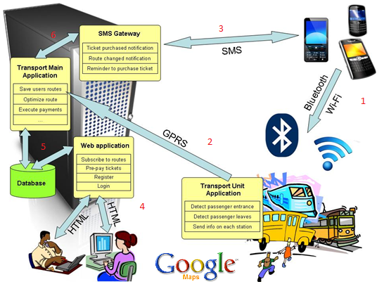
Figure 2 – General architecture of the Transport4U system
All of this is combined with modern development technologies such as: Java, MySQL, Hibernate, Apache Struts 2, etc.

Transport model and database design

The Transport Model is the model of the Transport4U system. The model primarily contains all the classes that belong to the domain. This module is completely decoupled without any complex behavior, making it an ideal component reused by most of the other components that make up the system.

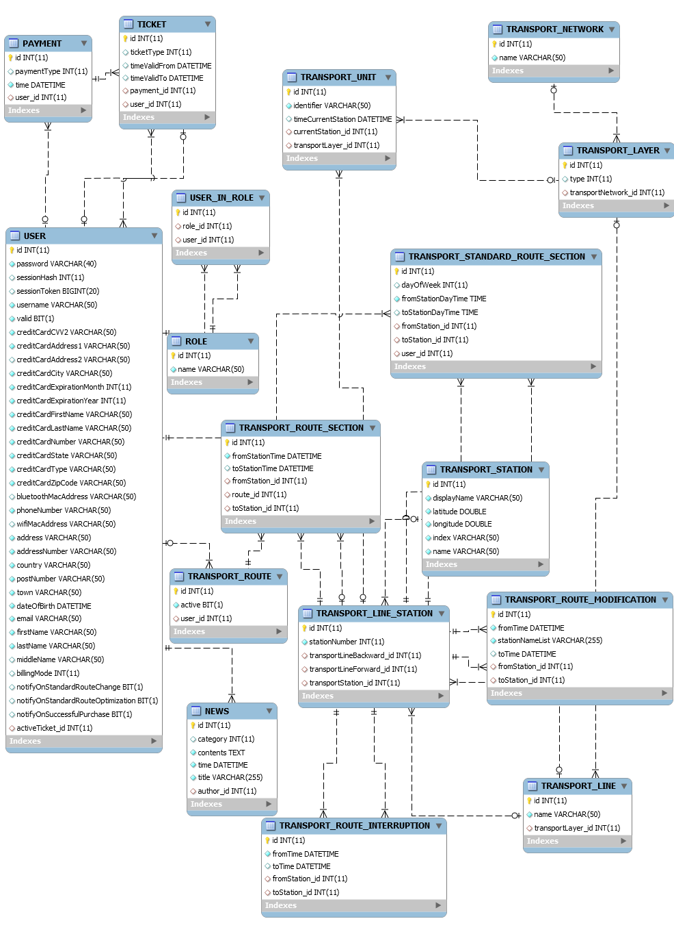
Figure 3 – Database ER diagram

Transport main application design
The Transport Main Application (TMA) is the mainframe of the Transport4U system. It contains the behavior of the system and it is composed of several sub-modules a) notification module, b) standard route identification module, c) user data handler module, d) billing handler module, e) payment module, f) route optimization module. All these modules represent general behavior of the Transport4U system and new implementations can be integrated, with the existing system, very easily. TMA is the server of the system and only one instance of this application is deployed.
Figure 4 represents class diagram for the TMA.

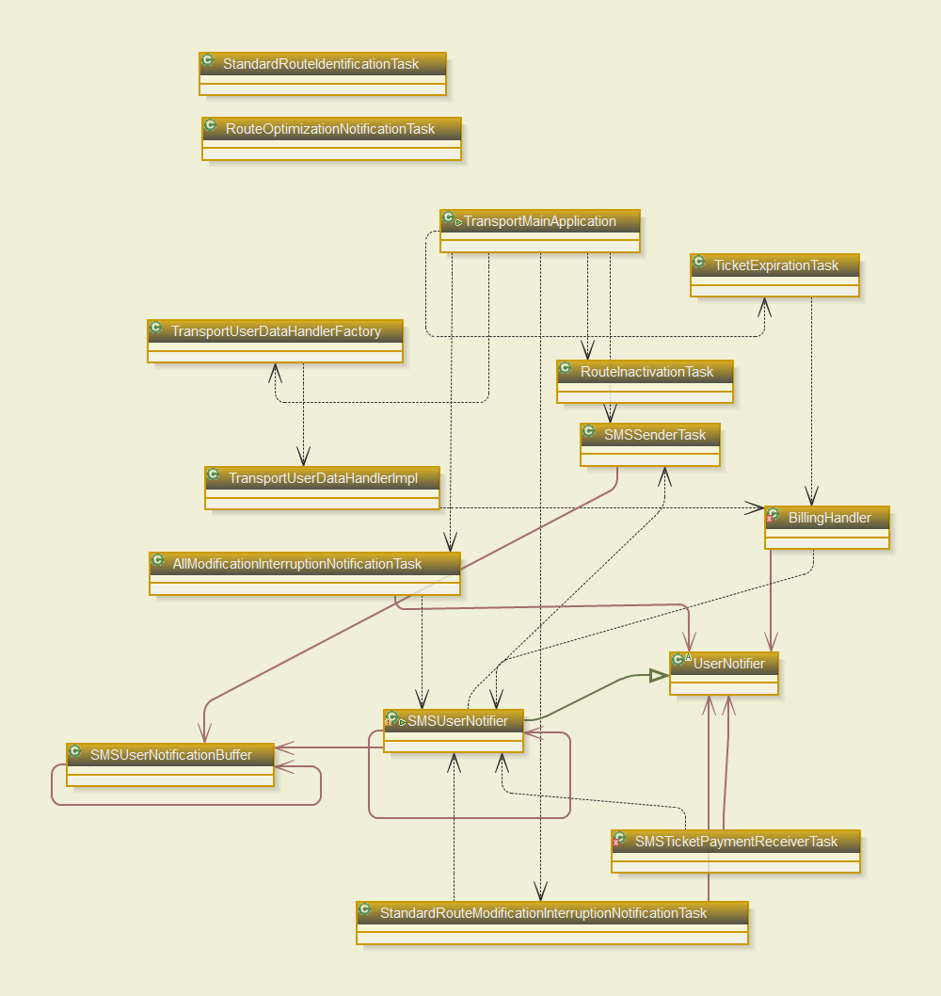
Figure 4 – TMA class diagram

Transport unit application
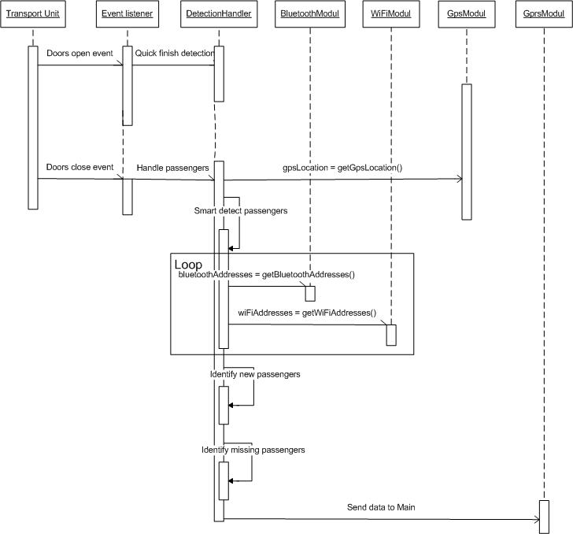
The Transport Unit Application (TUA) represents the application support which is deployed into each transport unit travelling around the transport network. TUA needs to handle events and identification of users inside a vehicle. It is composed of several sub-modules a) interfaces to external devices (Bluetooth, Wi-Fi, GPRS, GPS), b) smart detection module (algorithm for detection of users only inside a transport unit), c) event handler module (handler for events generated by a transport unit, such as doors opened, doors closed, etc.). The main purpose of the TUA is to detect users inside a transport unit and send this data back to TMA to be handled appropriately.
Figure 5- TUA Sequence Diagram
Figure 5 is a sequence diagram representing the behavior of the TUA. This module is event based, with and the main event “Door closed” triggering the smart detection of users. Once smart detection is finished, the collected data is sent to the TMA.

Figure 6 represents TUA class diagram.

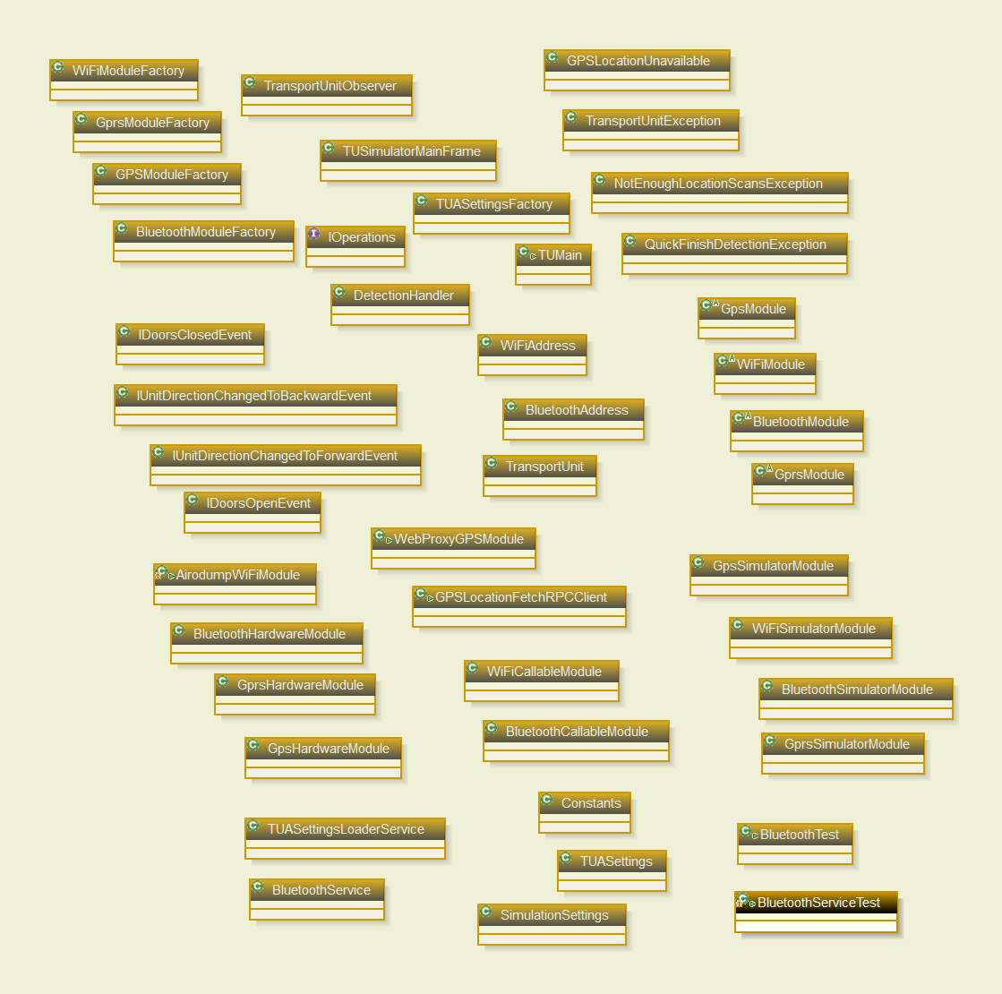
Figure 6 – TUA class diagram

Transport web application
The Transport Web Application (TWA) is Transport4U web interface. Main purpose of TWA is to offer users easy registration into the system. TWA is also used for presentation of news about transport network problems or changes. The administrative section of the application offers easy input of problems and changes to the network system. TWA and TMA are connected to the same persistence layer, making any additional coupling between the two applications unnecessary.
Figure 7 shows the basic flow and interactions between components of the Transport4U system, during a user’s journey. More advanced features, such as standard route identification or line interruption notification is not shown on this diagram.
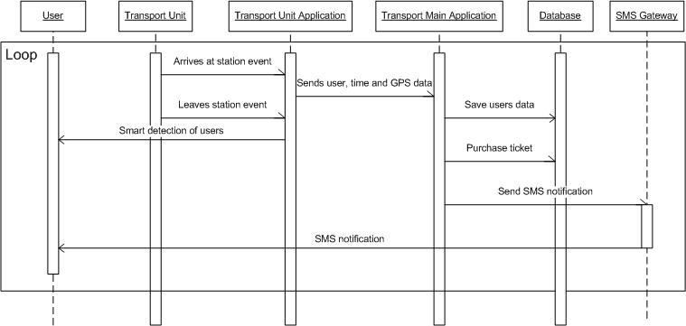
Figure 7 – Sequence diagram for automatic detection and billing of a user

Approvals

Name | Title | Date  yyyy-mm-dd | Signature

References

Note that all class members are hidden because of complexity of diagram
Note that all class members and references are hidden because of complexity of diagram
Mobile phone tethering: A method for connecting a computer to the internet via an internet-capable mobile phone.
Gnokii: (http://www.gnokii.org/) - Gnokii is a suite of programs for communicating with mobile phones.
Paypal sandbox: (https://developer.paypal.com) - A sandbox is a testing environment that isolates untested code changes and outright experimentation from the production environment or repository, in the context of software development including Web development and revision control.
Google maps: (http://maps.google.com/) - Google Maps (formerly Google Local) is a web mapping service application and technology provided by Google, free (for non-commercial use), that powers many map-based services, including the Google Maps website.
Java: (http://www.java.com/en/download/index.jsp) - Java is a programming language originally developed by James Gosling at Sun Microsystems (which is now a subsidiary of Oracle Corporation) and released in 1995 as a core component of Sun Microsystems' Java platform.
MySQL: (http://www.mysql.com/) - MySQL is a relational database management system that runs as a server providing multi-user access to a number of databases.
Hibernate: (http://www.hibernate.org/) - Hibernate is an object-relational mapping (ORM) library for the Java language, providing a framework for mapping an object-oriented domain model to a traditional relational database.
Apache Struts2: (http://struts.apache.org/2.x/index.html) - Apache Struts is an open-source web application framework for developing Java EE web applications.
GPRS: General packet radio service is a packet oriented mobile data service on the 2G and 3G cellular communication systems global system for mobile communications.
GPS: The Global Positioning System is a space-based global navigation satellite system (GNSS) that provides reliable location and time information in all weather and at all times and anywhere on or near the Earth when and where there is an unobstructed line of sight to four or more GPS satellites. It is maintained by the United States government and is freely accessible by anyone with a GPS receiver.

